INSIGHTSTREAM : NAVIGATE THE NEWS LANDSCAPES

(React Application)





GOVERNMENT ARTS AND SCIENCE COLLEGE

**19, POONTHOTTAM STREET**

|  |
| --- |
| INSIGHTSTREAM : NAVIGATE THE NEWS LANDSCAPES |

**THIRUVOTTIYUR ,CHENNAI-19**

Team ID: NM2025TMID37757

Team Size: 4

Team Leader: THILOTHAMMA B

Team Member: SNEHA S

Team Member: SURIYA S

**Team Member: VANAJA A**

## **INDEX**

## Introduction

## Description

## Key feathers

## Pre-requisites

## React.js

## Project flow

## Install dependencies

## Start the development server

## Access the App

## Project structure

## Project setup and configuration

## Project development

## Project implement &Execution

Introduction:

In Today’s Fast-Paced Digital Era, News Flows Across Countless Platforms, Shaping Opinions, Decisions, And Societies In Real Time. Yet, This Vast Information Stream Is Often Complex, Overwhelming, And Sometimes Unreliable. Insightstream: Navigate The News Landscapes Is Designed To Guide Readers Through This Evolving Media Environment—Helping Them Understand How News Is Created, Distributed, And Consumed. By Exploring Patterns, Biases, Technologies, And Global Perspectives, Insightstream Equips Individuals With The Tools To Critically Engage With Information, Separate Fact From Noise, And Make Informed Judgments.

DESCRIPTION:

Insightstream Is A Modern, Web-Based News Aggregation Platform Built To Transform How People Discover, Filter, And Consume News.

* Web-based news aggregation platform – built to collect and display news articles from multiple sources.
* Focus on navigation – helps users easily explore and organize news across categories.
* Real-time updates – fetches the latest stories dynamically through APIs.
* Smart discovery – allows searching for specific topics, keywords, or articles.
* User-centric design – includes bookmarking/favorites to save articles for later.
* Responsive interface – optimized for desktops, tablets, and mobile devices.
* Customizable experience – provides light/dark themes for comfortable reading.

**Key features:**

1. AI-Powered News Navigation – Smart filtering of reliable news.

2. Real-Time Updates – Instant access to trending stories.

3. Personalized Feeds – Customized content for each user.

4. Fact-Checking Tools – Verification to avoid misinformation.

5. Cross-Platform Access – Available on web & mobile.

The key features of InsightStream focus on making news consumption smarter, faster, and more reliable. It uses AI-powered navigation to filter through vast news sources and deliver content that matters most, while providing real-time updates to keep users informed on breaking stories.

**PRE-REQUISITES**

Here are the key prerequisites for developing a frontend application using React.js:

* **Node.js and npm**:

 Node.js is a powerful JavaScript runtime environment that allows you to run JavaScript code on the local environment. It provides a scalable and efficient platform for building network applications.

* Install Node.js and npm on your development machine, as they are required to run JavaScript on the server-side.
* **Download:** <https://nodejs.org/en/download/>
* Download **Node.js LTS version** from <https://nodejs.org/en/download/>
* Select your system configuration and click on
  + **Windows installer (.msi)** if windows

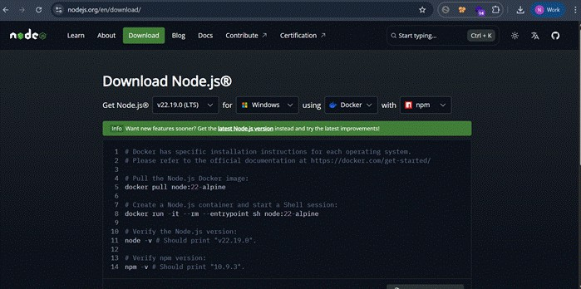

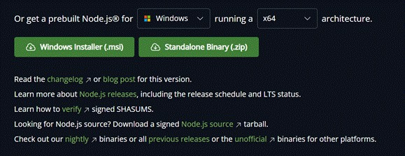

* After downloading, install Node.js by opening the downloaded file and follow the instructions below.

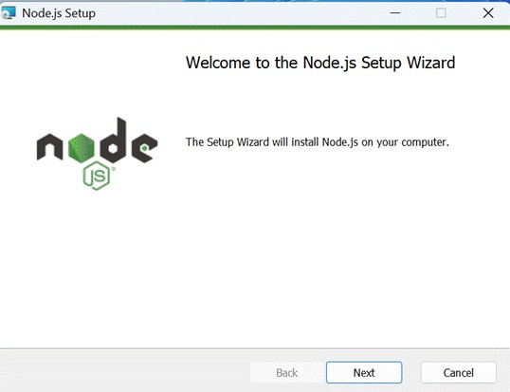

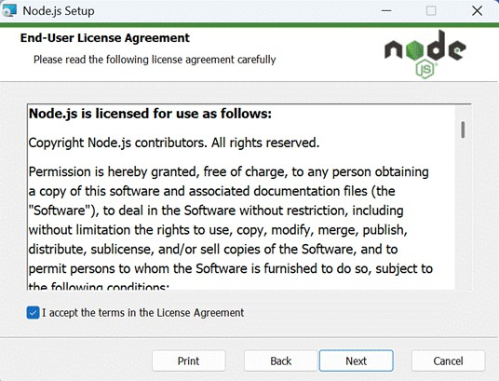

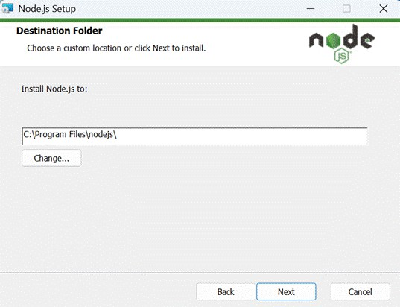

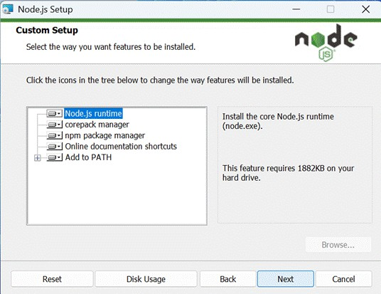

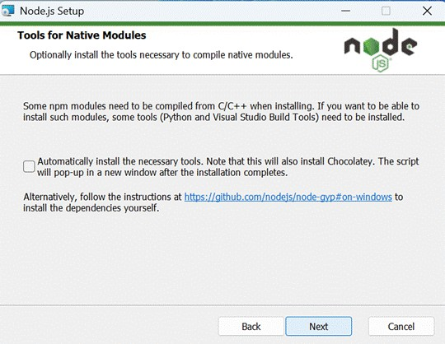

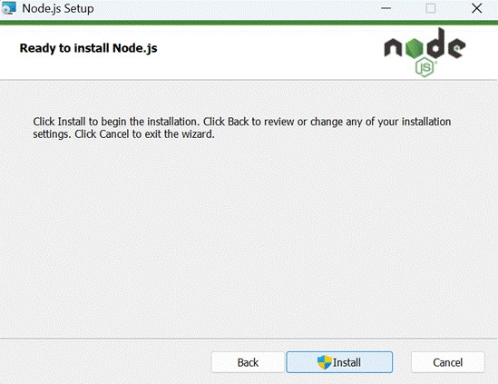

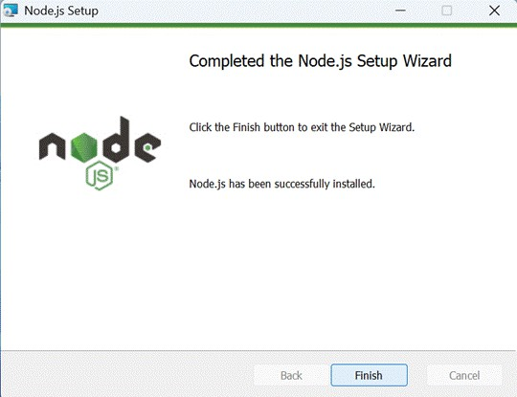

* After installing Node.js, open **Windows PowerShell As Administrator**

Type **set-executionPolicy unrestricted** and press enter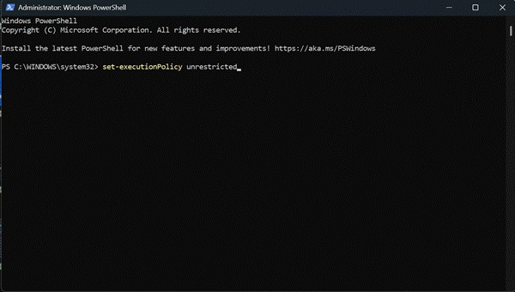

* In the next step type **Y** and press enter.

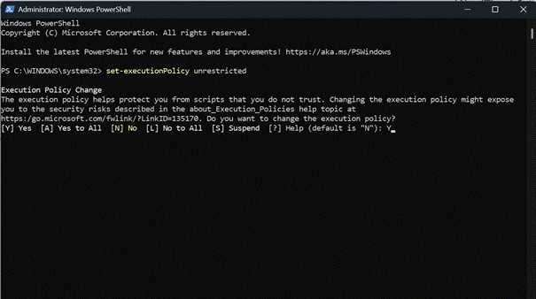

**React.js**:

React.js is a popular JavaScript library for building user interfaces. It enables developers to create interactive and reusable UI components, making it easier to build dynamic and responsive web applications.

Install React.js, a JavaScript library for building user interfaces.

* **Create a new React app:**npx create-react-app my-react-app

Replace my-react-app with your preferred project name.

* **Navigate to the project directory: cd my-react-app**
* Running the React App:

With the React app created, you can now start the development server and see your React application in action.

* Start the development server: **npm start**

This command launches the development server, and you can access your React app at http://localhost:3000 in your web browser.

* **HTML, CSS, and JavaScript:** Basic knowledge of HTML for creating the structure of your app, CSS for styling, and JavaScript for client-side interactivity is essential.
* **Version Control:** Use Git for version control, enabling collaboration and tracking changes throughout the development process. Platforms like GitHub or Bitbucket can host your repository.
  + Git: Download and installation instructions can be found at: <https://git-scm.com/downloads>
* **Development Environment:** Choose a code editor or Integrated Development Environment (IDE) that suits your preferences, such as Visual Studio Code, Sublime Text, or WebStorm.
  + **Visual Studio Code:** Download from <https://code.visualstudio.com/download>
  + **Sublime Text:** Download from <https://www.sublimetext.com/download>
  + **WebStorm:** Download from [https://www.jetbrains.com/webstorm/](https://www.sublimetext.com/download)

### Project Flow:

**Project demo:**

Before starting to work on this project, let’s see the demo.

**Demo link:** <https://drive.google.com/file/d/11uBQ3q6BK13SlFLz1ydlbM48QeqWecFL/view?usp=sharing>

**Use the code in:** <https://drive.google.com/drive/folders/1E9QxUsJfs_W1pTK3qt8lB_yWaYAecCWd?usp=drive_link>

**To clone and run the Application project from GitHub:**

**Follow below steps**

**Install Dependencies:**

* + **Navigate into the cloned repository directory and install libraries:**

**cd news**

**npm install**

* **Start the Development Server:**
  + **To start the development server, execute the following command:**

**npm start**

* **Access the App:** Open your web browser and navigate to http://localhost:3000.

You have successfully installed and set up the application on your local machine. You can now proceed with further customization, development, and testing as needed.

### Project structure:

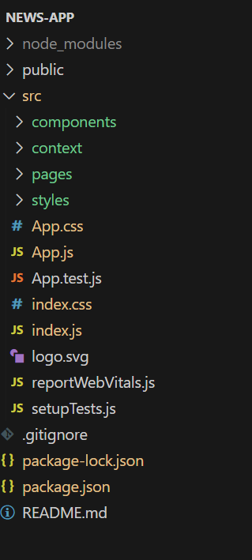      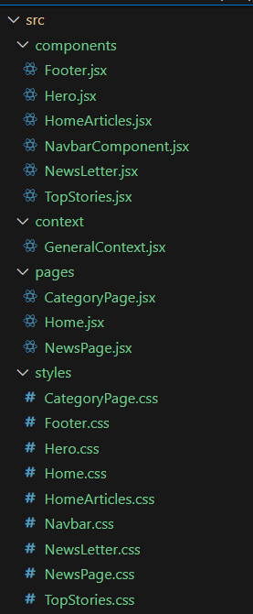

* In this project, we’ve split the files into 4 major folders, *Components, Context, Pages and Styles.* In the pages folder, we store the files that acts as pages at different URLs in the application.
* The components folder stores all the files, that returns the small components in the application. The context Api will be coded in the context folder.
* All the styling css files will be stored in the styles folder.

### Project setup and configuration:

* + **Installation of required tools**:

1. Open the project folder to install necessary tools

**In this project, we use:**

* + React Js
  + React Router Dom
  + sReact Icons
  + Bootstrap/tailwind css
  + Axios
* **For further reference, use the following resources**
  + <https://react.dev/learn/installation>
  + <https://react-bootstrap-v4.netlify.app/getting-started/introduction/>
  + <https://axios-http.com/docs/intro>
  + <https://reactrouter.com/en/main/start/tutorial>

### Project Development

* **Project Development**
  + Setup the Routing paths

Setup the clear routing paths to access various files in the application.

* + Develop the Navbar and Hero components
  + Code the popular categories components and fetch the categories from ***newsapi***.
  + Also, add the trending news in the home page.
  + Additionally, we can add the component to subscribe for the newsletter and the footer.
  + Now, develop the category page to display various news articles under the different categories.

**Important Code snips:**

* + **Fetching Top/Trending news**
  + **Fetching news by search/category**

### Project Implementation & Execution

### Home

### 

### General

### 

### Technology

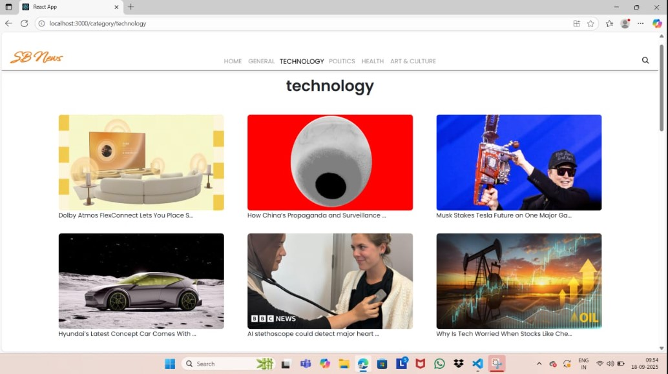

### P0litics

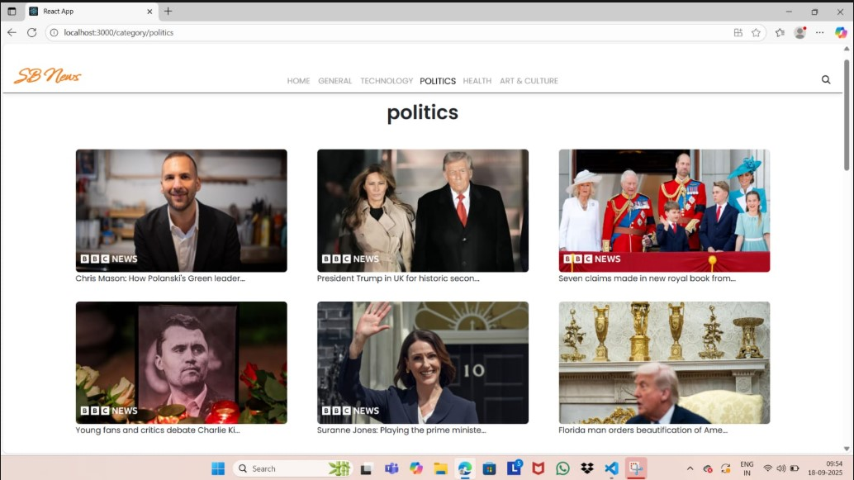

Health

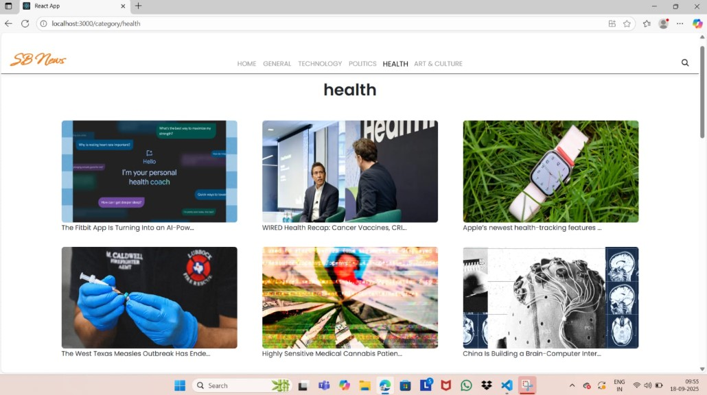

### Art & Culture

